ELEG 312 - Example Problems Appendix E

**Example E.1**

Reduce the circuit in Fig. E.1(a) to an STC circuit, and find its time constant.

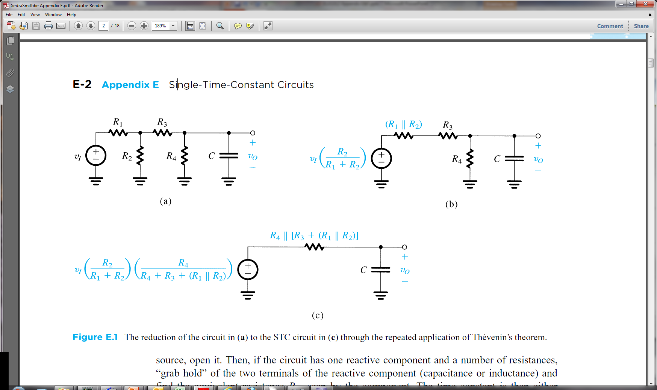

**Example E.2**

Find the time constant of the circuit in Fig. E.2.

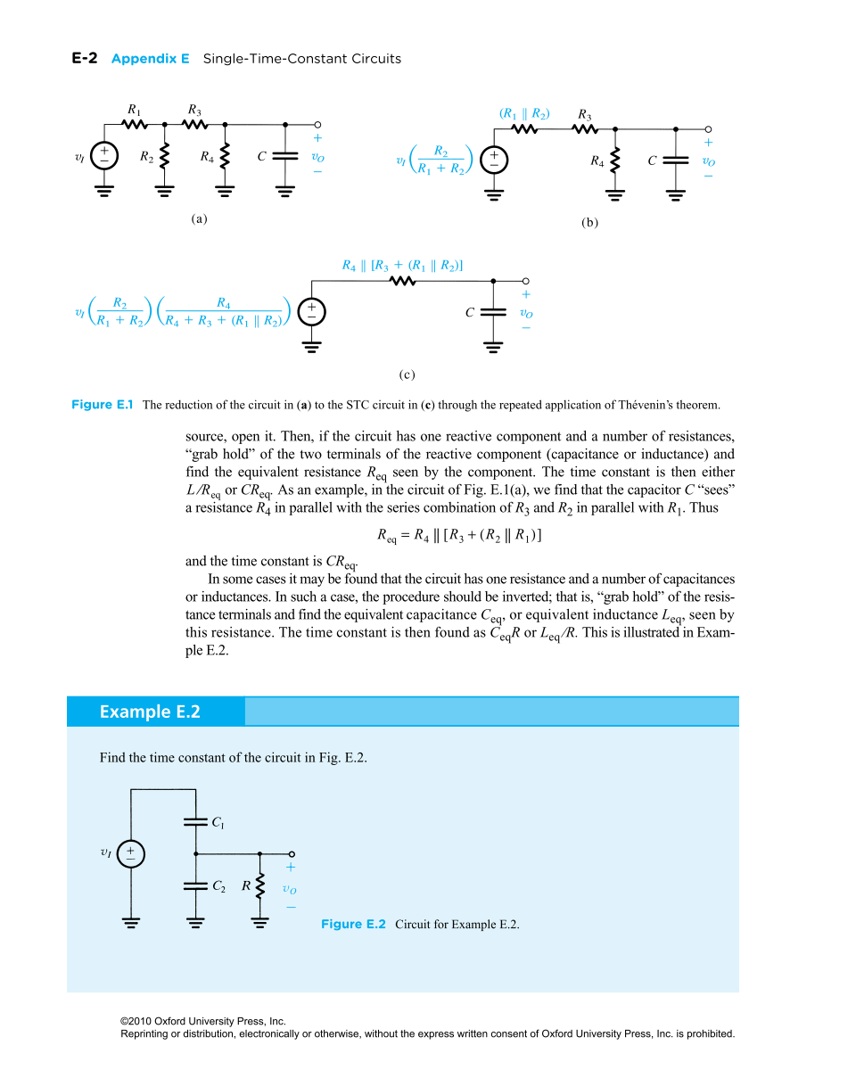

**Exercise E.1**

Find the time constants for the circuits shown in Fig. EE.1.

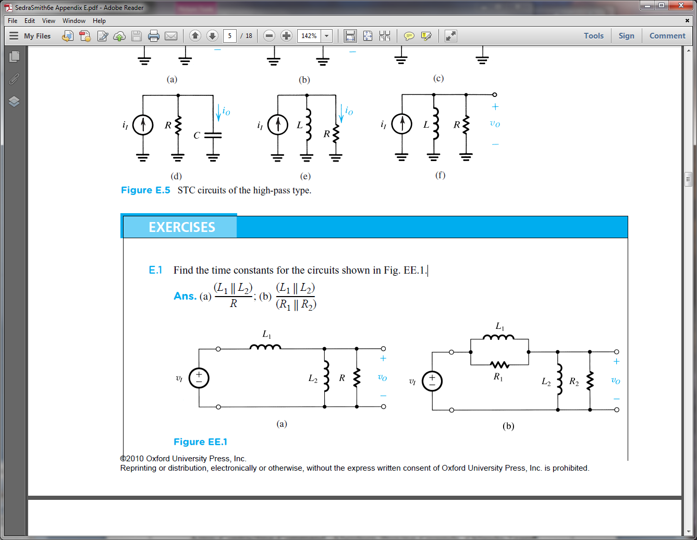

**Example E.4**

Consider the circuit shown in Fig. E.7(a), where an ideal voltage amplifier of gain µ = –100 has a small (10-pF) capacitance connected in its feedback path. The amplifier is fed by a voltage source having a source resistance of 100 k. Show that the frequency response *Vo/Vs* of this amplifier is equivalent to that of an STC circuit, and sketch the magnitude response.

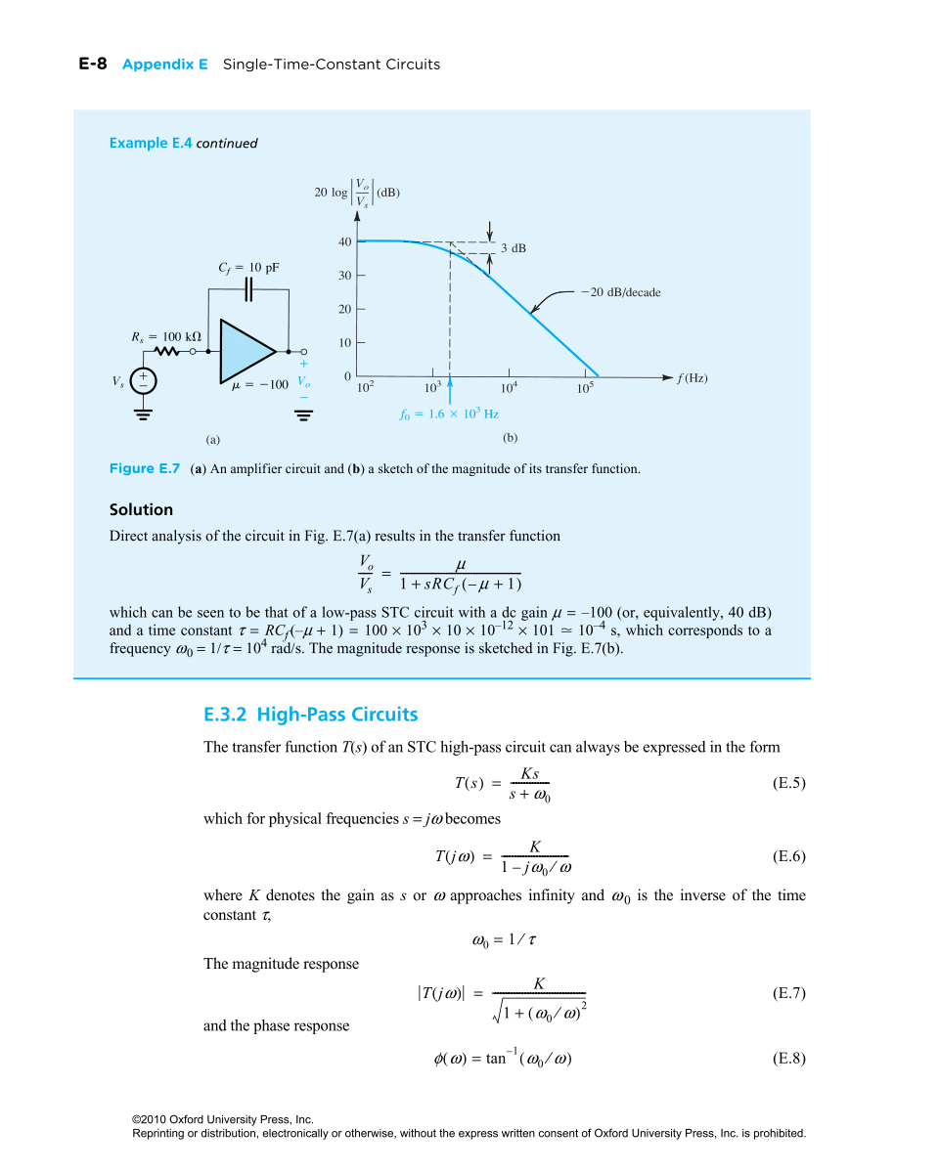



**Exercise E.3**

Find the dc transmission, the corner frequency *f*0, and the transmission at *f* = 2 MHz for the low-pass STC circuit shown in Fig. EE.3.

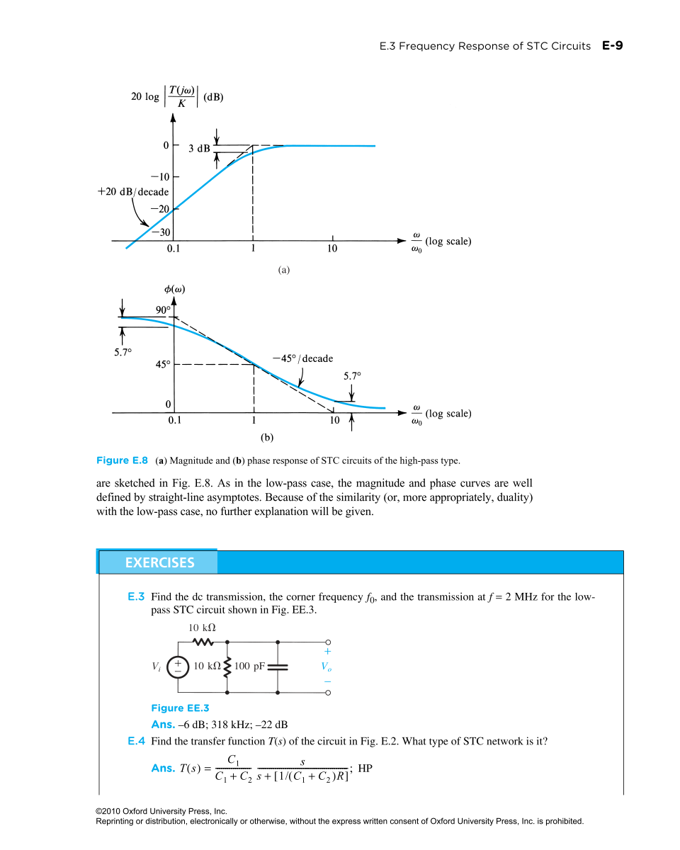

**Exercise E.6**

Find the high-frequency gain, the 3-dB frequency *f*0, and the gain at *f* = 1 Hz of the capacitively coupled amplifier shown in Fig. EE.6. Assume the voltage amplifier to be ideal.

